REGISTRATION INFORMATION FOR WISE 2KM AT OTTAWA RACE WEEKEND

To start, please click on http://www.runottawa.ca/races-and-events/tamarack-ottawa-race-weekend/weekend-information/scotiabank-charity-challenge/participating-charities/ to get to this web page.
Click on “W” to get to WISE.

Select “Register to Run” – for those not running, click on “Donate”.

FOR RUNNERS, SCREEN WILL LOOK LIKE THIS: FOR DONORS, SCREEN WILL LOOK LIKE THIS:
Select the 2km race, then click submit You’re able to donate directly online
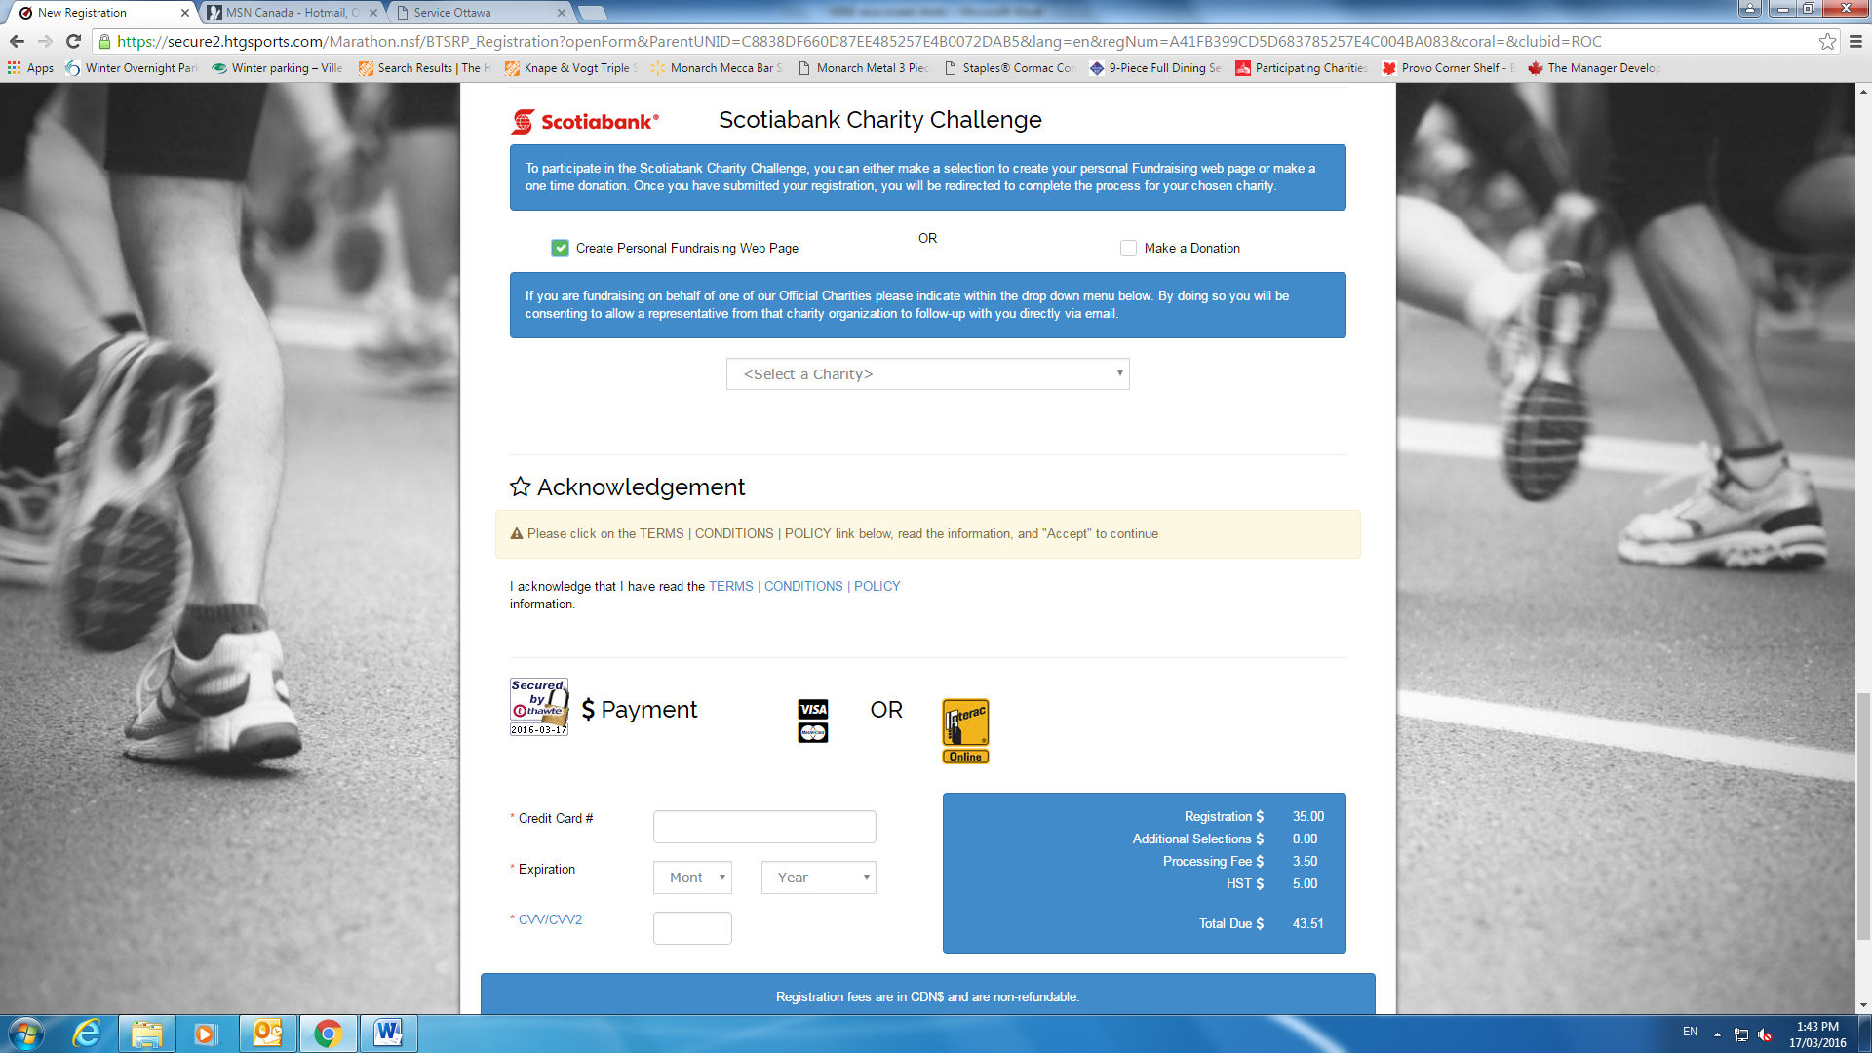
FOR RUNNERS: This screenshot is after you’ve put in your contact information, and right before you pay the registration fee of $43.51 ($35 + tax and fees). Click on “Create personal fundraising page” and Select “Women’s Initiatives for Safer environments” from the drop down menu.

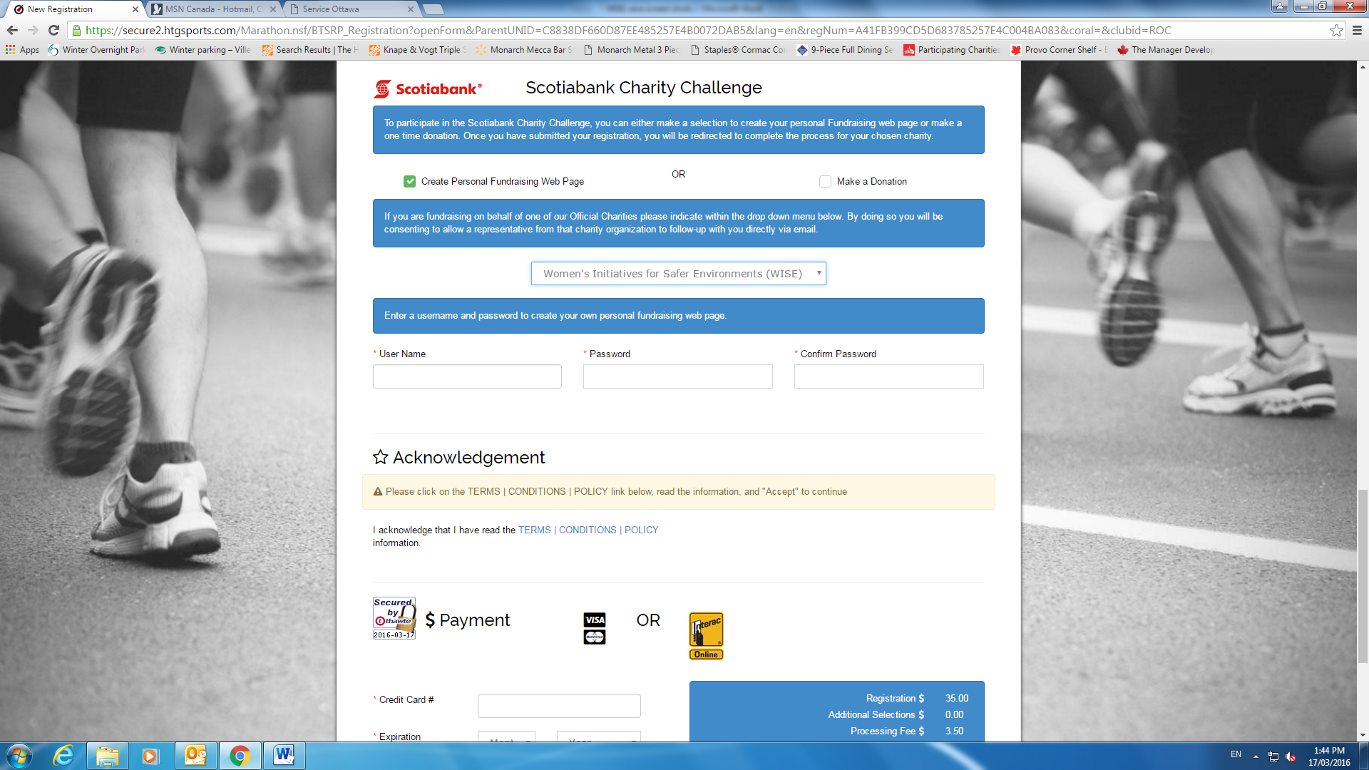
You’ll be prompted to create a username and password to get back into your fundraising page, and then pay the required fees.
This is what the fundraising page looks like. Click on the “Get sponsors” button ……..

…in order to send a personalized email to your contacts about financial support. A standard message is already populated, but you can manipulate it to explain what WISE does and what the funds raised will be used for. THAT’S IT!!!

